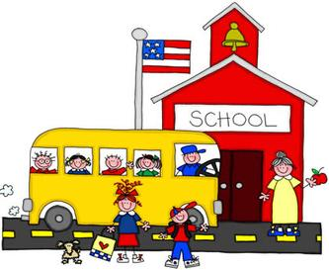
Hello,
I would like to welcome you and your child to our third-fourth grade discovery class. This will be an exciting year of many new experiences.
Let me introduce myself, I’m Mrs. Warner. I have a bachelor’s degree from The Ohio State University, a master’s degree from Miami University, and a PhD from The Ohio State University. I have taught many grades from pre-K to high school. I have completed my reading and gifted education endorsements.
Your child’s take home folder needs to be returned to school every day. All pick-up notes, correspondence, lunch money, and anything else that needs to be returned to school belongs in this folder. Your child will bring it into the room first thing every morning. Lunch money needs to be in a sealed envelope or sealed plastic bag labeled with their name, grade, and teacher’s name on the outside of the envelope or bag.
The first day of school is Monday, August 28th. The tardy bell rings at 8:50 (plan to arrive at 8:40 if they are eating breakfast). They may also bring a clear, labeled bottle of water (water only) to have with them in the classroom. Please be sure the cap fits tightly. It will need to be taken home at the end of every day.
The emergency medical form needs to be checked and corrected, if necessary and returned to school as soon as possible. Please be sure to read and return any papers to school as soon as possible, if needed. Please post the specials calendar at home.
I look forward to meeting you and teaching your child during the 2017-2018 school year. If you have any questions, please feel free to contact me (email is the best). You may leave a message at the office and I will contact you as soon as possible. Thank you for all of your support.
Sincerely,
Mrs. Warner
vwarner@gcswave.com

