Dear Parents,
Welcome to another school year, and to our first August and September in our new building! I’m even more excited than I was back in January. The technology in our classroom continues to amaze me, with our smartboard, sound system, and new iPad* programs like eSpark and Ten Marks Math. I hope you will become excited as you participate in and track your child’s progress this year.
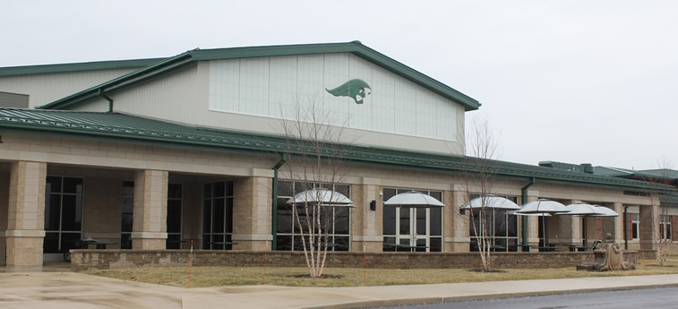
Please check book bags and assignment books every day for notes, reports, and assignments.
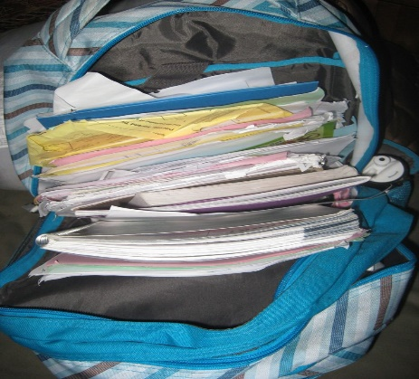

We are continuing our school wide behavior incentive program called the “Rainbow of Respect.” Each day students earn a color that represents their behavior for the day. Check your child’s calendar in the back of his Take Home folder for the color code and your child’s earned color for each day. Don’t forget to give positive attention for their good days!
This Photo by Unknown Author is licensed under CC BY

* WHEN IPADS ARE SENT HOME, PLEASE ENSURE THAT THEY ARE CHARGED AND RETURNED DAILY

OUR LEARNING TARGETS:

Every month I will post our class learning targets so that you will know what concepts we are working on. Here they are by subject area:

LANGUAGE ARTS: I can follow directions and procedures. I can define words in the context of a story. I can spell words at my grade level accurately and fluently.

MATH: I can add and subtract whole numbers. I can count by 1’s, 5’s, and 10’s within 100. I can identify quadrilaterals.

SOCIAL STUDIES: I can locate points and follow directions on a map. I can use cardinal and intermediate directions to find a specific location.

SCIENCE: I can describe the orbits of the moon, earth, and planets. I can name the planets in their order from the sun.

