Marketing Program 2017-2018

First Quarter News Release
____________________________________________________________________________________
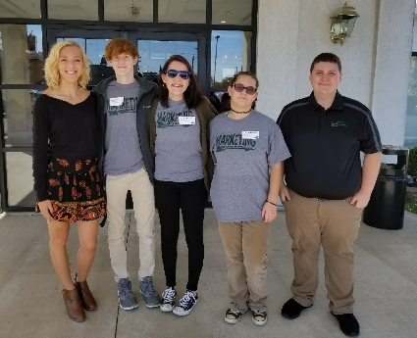
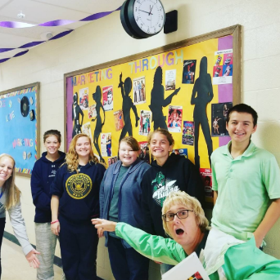
The 2017-2018 Marketing Program at Greenville Senior High School has been very busy this school year! Students have been taking classes such as Marketing Communications, Marketing Principles, Strategic Entrepreneurship, and Marketing Capstone, while some also play high school sports and hold down internships. Officers elected to represent the program this year include RJ Smith (President), Mikayala Miller (Vice President), Rachel Unger (Secretary), Makayla Thornton (Treasurer), and Aaron Matthew (Public Relations Coordinator).
‘Through the Decades’ was this year’s homecoming theme, and one of the first projects marketing students got involved with by making hall decorations for the event. Students chose to highlight the program by displaying different types of advertising through the decades, discussing how and why advertising has changed, due to factors such as technology and events that shaped the minds and attitudes of consumers.
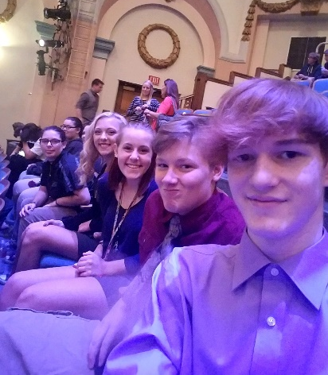
Business Professionals of America is a national CTSO (Career Technical Student Organization) marketing students have had the opportunity to get involved with this quarter by contributing to the BPA mission of preparing for a world-class workforce through the advancement of leadership, citizenship, and academic/technological skills. On October 3, 2017, all students attended the BPA Fall Leadership conference at Memorial Hall, where Region 3 Officers were announced, and a Torch Ceremony was held. BPA is a great program that helps to strengthen our students and prepare them to be “Tomorrow’s Business Professionals.” We are looking forward to competitions later in the school year.
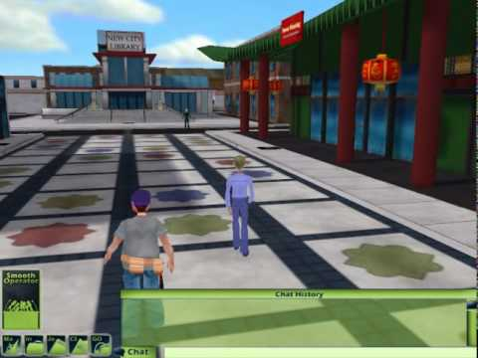
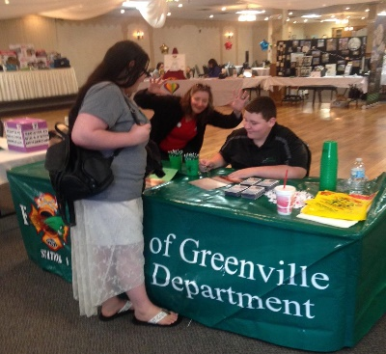
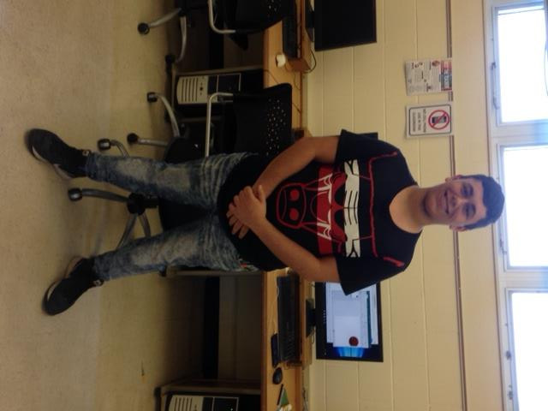
Seven teams from the Marketing Program have been participating in Deloitte’s Virtual Team Challenge again this quarter. This is an online business simulation and national competition where students learn key skills they can apply in their future careers, such as business ethics, negotiation skills, communication, professionalism, and decision-making. The ‘SPILL’ simulation takes place in the animated 3D world of New City after an oil spill on the New City River. The team’s business objective is to help the mayor stage the most efficient oil spill recovery effort. Top-performing teams are eligible for prizes for themselves, their schools, and local charities. This competition will wrap up towards the end of November.
Marketing students also recently volunteered at Darke County’s 4th Annual County and City Health and Wellness Fair on October 19, 2017. The event, held at Romer’s Catering, had multiple vendors that came together to promote positive and healthy lifestyles for county and city employees. This year’s theme was “Be Healthy, Be Fit, Be Happy.” In addition to passing out boxed lunches and directing visitors, Marketing Communications students collaborated to design various signs, decorations and flyers promoting the event.
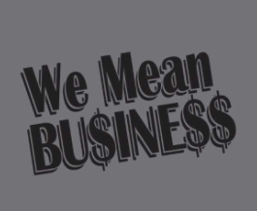
Another opportunity Marketing and Entrepreneurship students recently took advantage of this quarter was hearing and learning from Ryan Wintrow, a 2016 alumni of the Marketing Program. As a junior in high school, Ryan opened Go Go Gamers, a video gaming center in Greenville. Students learned about the skill it takes to be an entrepreneur and start your own business, as well the marketing strategies behind it. Seniors in Strategic Entrepreneurship are currently forming business plans for their own theoretical businesses in the industries of lawn care, pet care, freelance writing, and auto repair.
Lastly, seniors in the Marketing Capstone course have been learning employability skills through internships again this year. By participating in an internship, students are able to receive two credits for the course and are able to leave 10th period of school to work. Marketing students’ internship placements are throughout the Greenville and Darke County community and average 12-15 plus hours a week.
Future Important Marketing Dates:
- Sinclair Exploration Day: November 8, 2017 (Juniors and Seniors)
- Local Business Tour: December 1, 2017 (Entrepreneurship students)
- Regional BPA competition begins: January 23, 2018 (MVCTC)
- End of the Second Quarter/1st Semester: January 19, 2018
- Region 3 awards for BPA: Early February 2018 at Memorial Hall

If you are an employer looking for part-time employees, or if you have an opportunity for our students to get involved in the community, please contact Kristi Homan, Marketing Coordinator, at Khoman@gcswave.com or call 937-548-4188.
Editors: Aliyah Pike, Makayla Thornton, RJ Smith, David Printz, Meetkumar Patel, and Tristan Rollins
###

