Dear Parents,
Welcome to Fall! Our students now have an established routine in Room 107. They remember the room rules for the Rainbow of Respect. They have had opportunities to earn funny money for prizes. We have shopping day once a week, usually on Fridays. It is expected that any toys coming from the prize box will be left at home! Recently, we have started an incentive program to help students achieve an individual behavior goal. This month, if students earn 10 stickers for exhibiting their “goal behavior” they may earn a french fry treat, pending parent approval. This is meant to be a fairly rare occasion; eventually we will work up to 50 stickers as we fade the incentive to encourage more and more independent mastery of each student’s goal behaviors.
Please check book bags and assignment books every day for notes, reports, and assignments. Don’t forget to sign or initial your child’s agenda book!
IMPORTANT DATES
October 30: Teacher Inservice (no school)
October 17 & 31: Parent-Teacher conferences

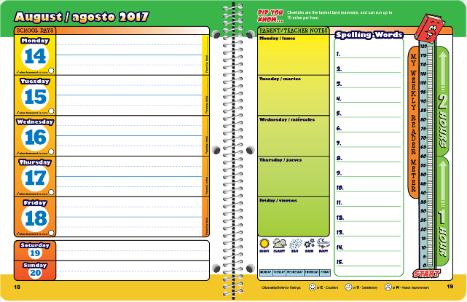

I can follow directions the first time I hear them.
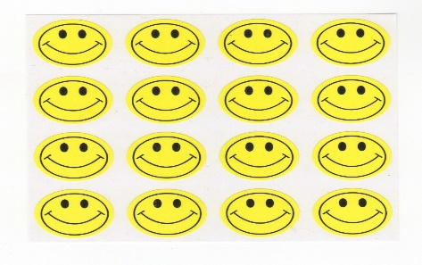

OUR LEARNING TARGETS:

LANGUAGE ARTS: I can use text features (diagrams, maps, captions, subheadings) to help me understand the text.
I can describe the characters, setting, and plot of a story.
I can spell words with long and short vowel patterns.

MATH: I can add and subtract whole numbers. I can count by 1’s, 5’s, and 10’s within 100. I can round numbers to the nearest 10. I can estimate sums and differences.

SOCIAL STUDIES: I can locate points and follow directions on a map. I can use cardinal and intermediate directions to find a specific location. I can name the 7 continents, 5 oceans, and 6 common imaginary lines of the earth.

SCIENCE: I can describe the details and attributes of rocks. I can describe how rocks are formed. I can classify rocks according to their attributes.

