NOVEMBER NEWSLETTER 2018

[**www.XtraMath.org**](http://www.XtraMath.org) - please help your child learn their multiplication facts by encouraging them to get on XtraMath.org to practice

If students do not take their Ipads home they can still access TenMarks.com at home without a fee. Please have them do this so they can complete assignments. Go to [www.tenmarks.com](http://www.tenmarks.com), select student and sign in.

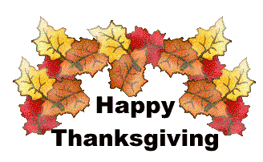

**Science-** We will be finishing our weathering and erosion unit with sand table labs. Students always enjoy these labs. They will receive a study guide this week to prepare them for unit test next week.

**IMPORTANT DATES TO REMEMBER**

Weekly quizzes over multiplication facts on Friday.

Nov. 28 – Scholastic book orders due (class code is H8GQ6 for Walling)

Thanksgiving break begins Nov. 21. Students will return on Nov. 26.

A **Family History Project** begins this month. This will be ongoing for the next three months. More information coming.

Harvest Party will be Nov. 20. Notes will be coming home this week for the food donations for the party. REMINDER: If your child has received more than FIVE reds on the rainbow of respect, they will not be able to participate at the party.

Contact Me – [mwalling@gcswave.com](mailto:mwalling@gcswave.com)

**Math I can statements**

**I can use multiplication to estimate quotients.**

**I can use models to divide evenly.**

**I can use remainders to interpret division problems.**

**I can divide whole numbers through thousands.**

**I can use the distributive property to find quotients.**

**Mrs. Walling’s Science**

I can learn what energy is.

I can learn different sources of energy.

**Mrs. Walling’s Social Studies**

How were the early people of Ohio affected by the environment?

How did the early people change the environment?.